Four Year Integrated B.A. B.Ed. Degree Programmes
Session 2018-19, 2019-20

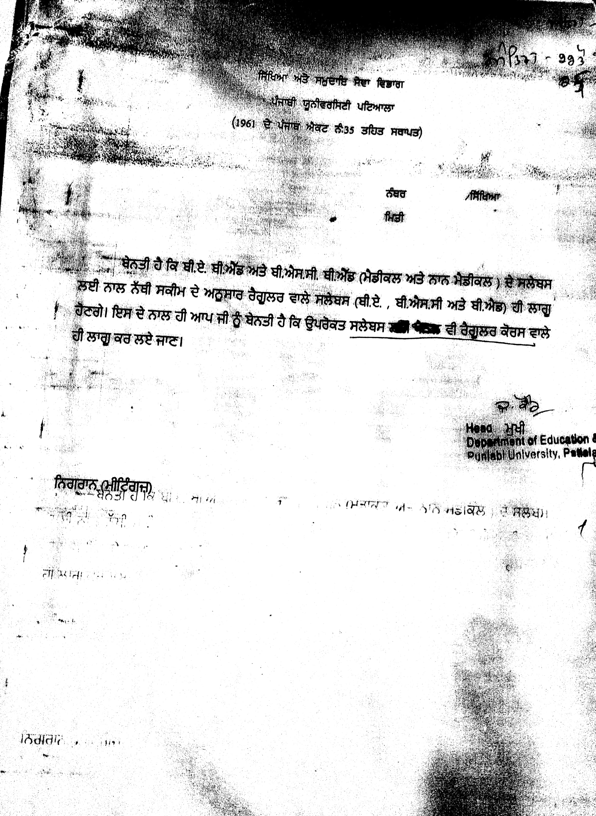

Four Year Integrated B.A. B.Ed. Degree Programmes
Session 2018-19, 2019-20

Semester-I
Paper | Course Title | Marks
 |  | T | E | I
I | Philosophical Perspective in Education | 100 | 70 | 30
II | Understanding the Learner | 100 | 70 | 30
III | Punjabi (Compulsory) | 100 | 75 | 25
V | English (Communication skills | 100 | 75 | 25
* V(1) | Punjabi Elective/ English Elective / Hindi Elective
V (2) | Philosophy
 | Psychology
 | Sociology
 | History
 | Economics
 | Political Science
 | Geography
 | Mathematics
 | Public Administration
 | Physical Education
 | Religious Study
 | Computer Application

*Note- For language teachers, students will opt for one paper from V (1) & two papers from V(2)
For social science teachers, students will opt for three papers from V(2)

Four Year Integrated B.A. B.Ed. Degree Programmes
Session 2018-19, 2019-20

Semester-II
Paper | Course Title | Marks
 |  | T | E | I
I | Education Policy & Planning in Contemporary India | 100 | 70 | 30
II | School Management | 100 | 70 | 30
III | Punjabi (Compulsory) | 100 | 75 | 25
V | English (Communication skills | 100 | 75 | 25
* V(1) | Punjabi Elective/ English Elective / Hindi Elective
V (2) | Philosophy
 | Psychology
 | Sociology
 | History
 | Economics
 | Political Science
 | Geography
 | Mathematics
 | Public Administration
 | Physical Education
 | Religious Study
 | Computer Application

Four Year Integrated B.A. B.Ed. Degree Programmes
Session 2018-19, 2019-20

Semester-III

Paper | Course Title |  | Marks
 |  | T | E | I
I | Teaching-Learning Process | 100 | 70 | 30
II | Exploring Library and Learning Resources | 50 | 35 | 15
III | Punjabi(compulsory) | 100 | 75 | 25
IV | English(communication skills) | 100 | 75 | 25
V(1) | Punjabi Elective/English Elective/Hindi Elective
V (2) | Philosophy
 | Psychology
 | Sociology
 | History
 | Economics
 | Political Science
 | Geography
 | Mathematics
 | Public Administration
 | Physical Education
 | Religion
 | Computer Application

Four Year Integrated B.A. B.Ed. Degree Programmes
Session 2018-19, 2019-20

Semester-IV

Paper | Course Title |  | Marks
 |  | T | E | I
I | Sociological Perspective In Education | 100 | 70 | 30
II | Knowledge and Curriculum | 50 | 35 | 15
III | Punjabi(compulsory) | 100 | 75 | 25
IV | English(communication skills) | 100 | 75 | 25
V(1) | Punjabi Elective/English Elective/Hindi Elective
V (2) | Philosophy
 | Psychology
 | Sociology
 | History
 | Economics
 | Political Science
 | Geography
 | Mathematics
 | Public Administration
 | Physical Education
 | Religion
 | Computer Application

**All UG Courses - II Year(Annual & 4th Semester)
Environmental and Road Safety Awareness
Session: 2017-18, 2018-19

Four Year Integrated B.A. B.Ed. Degree Programmes
Session 2018-19, 2019-20

Semester-V

Paper | Course Title |  | Marks
 |  | T | E | I
I | Pedagogy of a School Subject (Part I) | 50 | 35 | 15
II | Pedagogy of a School Subject (Part I)Any two of the following:  Languages  - Teaching of English  - Teaching of Punjabi  - Teaching of Hindi  - Teaching of Urdu  - Teaching of Sanskrit  Science  - Teaching of Science  - Teaching of Physical Science  - Teaching of Life Science  Mathematics  - Teaching of Mathematics  Computer Science  - Teaching of Computer Science  Commerce  - )Teaching of Commerce  Social Sciences  - Teaching of Social Studies  - ) Teaching of Economics  - ) Teaching of Geography  - Teaching of Political Science  - Teaching of History  Home Science  - Teaching of Home Science  Agriculture  - ) Teaching of Agriculture  Fine Arts  - Teaching of Fine Arts  Music  - Teaching of Music  Physical Education  - Teaching of Physical Education | 50 | 35 | 15
III | Punjabi(compulsory) | 100 | 75 | 25
IV | English(communication skills) | 100 | 75 | 25
V(1) | Punjabi Elective/English Elective/Hindi Elective
V (2) | Philosophy
 | Psychology
 | Sociology
 | History
 | Economics
 | Political Science
 | Geography
 | Mathematics
 | Public Administration
 | Physical Education
 | Religion
 | Computer Application
VI | Arts in Education | 50 | 35 | 15

Four Year Integrated B.A. B.Ed. Degree Programmes
Session 2018-19, 2019-20

Semester-VI

Paper | Course Title |  | Marks
 |  | T | E | I
I | Pedagogy of a School Subject (Part II) | 50 | 35 | 15
II | Pedagogy of a School Subject (Part II)Any two of the following:  Languages  - Teaching of English  - Teaching of Punjabi  - Teaching of Hindi  - Teaching of Urdu  - Teaching of Sanskrit  Science  - Teaching of Science  - Teaching of Physical Science  - Teaching of Life Science  Mathematics  - Teaching of Mathematics  Computer Science  - Teaching of Computer Science  Commerce  - )Teaching of Commerce  Social Sciences  - Teaching of Social Studies  - ) Teaching of Economics  - ) Teaching of Geography  - Teaching of Political Science  - Teaching of History  Home Science  - Teaching of Home Science  Agriculture  - ) Teaching of Agriculture  Fine Arts  - Teaching of Fine Arts  Music  - Teaching of Music  Physical Education  - Teaching of Physical Education | 50 | 35 | 15
III | Punjabi(compulsory) | 100 | 75 | 25
IV | English(communication skills) | 100 | 75 | 25
V(1) | Punjabi Elective/English Elective/Hindi Elective
V (2) | Philosophy
 | Psychology
 | Sociology
 | History
 | Economics
 | Political Science
 | Geography
 | Mathematics
 | Public Administration
 | Physical Education
 | Religion
 | Computer Application
VI | Arts in Education | 50 | 35 | 15

Four Year Integrated B.A. B.Ed. Degree Programmes
2019-20, 2020-21
Semester-VII

Paper | Course Title |  | Marks
 |  | T | E | I
I | School Internship – Subject I | 130 | 100 | 30
II | School Internship – Subject II | 130 | 100 | 30
III | Engagement With Community | 40 | 25 | 15
 |  | 300 | 225 | 75

Four Year Integrated B.A. B.Ed. Degree Programmes
2019-20, 2020-21

Semester-VIII

Paper | Course Title |  | Marks
 |  | T | E | I
I | Assessment for Learning | 100 | 70 | 30
II | Gender, School and Society | 50 | 35 | 15
III | Inclusive School | 50 | 35 | 15
IV | Understanding the Self | 50 | 35 | 15
V | Reading and Reflecting on Texts | 50 | 35 | 15
VI | Strengthening Language Proficiency | 50 | 35 | 15
VII | Health and Physical Education | 50 | 35 | 15
VIII & IX | Optional Courses (Any Two)
(i) | Guidance and Counseling | 50 | 35 | 15
(ii) | Human Rights and Value Education | 50 | 35 | 15
(iii) | Environment Education | 50 | 35 | 15
(iv) | Distance and Open Learning | 50 | 35 | 15
(v) | Teacher Education | 50 | 35 | 15
(vii) | Life Skills Education | 50 | 35 | 15
(viii) | Special Education | 50 | 35 | 15
(ix) | Comparative Education | 50 | 35 | 15
(x) | Vocational Education | 50 | 35 | 15
Total |  | 500 | 350 | 150

Four Year Integrated B.Sc B.Ed. (Medical/ Non Medical) Degree Programmes
Session 2018-19, 2019-20
Semester-I
Paper | Course Title | Marks
 |  | T | E | I
I | Philosophical Perspective in Education | 100 | 70 | 30
II | Understanding the Learner | 100 | 70 | 30
III | Punjabi (Compulsory) | 100 | 75 | 25
V | English (Communication skills | 100 | 75 | 25
 | Mathematics : Differential Equation's
 | Mathematics : Coordinate Geometry
 | Physics : Mechanics-I
 | Physics : Vibrations & Waves-I
 | Physics : Electricity and Magnetism -I
 | Practical Physics
 | Chemistry : Inorganic Chemistry
 | Chemistry : Organic Chemistry
 | Chemistry : Physical Chemistry
 | Practical Chemistry
 | Zoology : Cell Biology
 | Zoology : Biodiversity-I
 | Practical Zoology
 | Botany : Diversity of Microbes
 | Botany : Diversity of Cryptograms
 | Practical Botany
 | Computer Applications : Fundamentals of Information Tech.
 | Information Technology : Fundamentals of Information Technology & MS Office

Four Year Integrated B.SC (Medical/ Non Medical). B.Ed. Degree Programmes
Session 2018-19, 2019-20

Semester-II
Paper | Course Title | Marks
 |  | T | E | I
I | Education Policy & Planning in Contemporary India | 100 | 70 | 30
II | School Management | 100 | 70 | 30
III | Punjabi (Compulsory) | 100 | 75 | 25
V | English (Communication skills | 100 | 75 | 25
 | Mathematics : Algebra-I
 | Mathematics : Partial Differential Equation
 | Mathematics : Analytic Geometry
 | Physics : Mechanics-II
 | Physics : Vibrations and Waves-II
 | Physics : Electricity and Magnetism-II
 | Practical Physics
 | Chemistry : Inorganic Chemistry
 | Chemistry : Organic Chemistry
 | Chemistry : Physical Chemistry
 | Practical Chemistry
 | Zoology : Biodiversity
 | Zoology : Ecology
 | Zoology Practical
 | Botany : Cell Biology
 | Botany : Genetics and Evolution
 | Practical Botany
 | Computer Applications : Windows and Office Automation
 | Information Technology : Windows and Office Automation
 | Drug Abuse Problem Management and Prevention

Four Year Integrated B.SC (Medical/ Non Medical). B.Ed. Degree Programmes
Session 2018-19, 2019-20

Semester-III

Paper | Course Title |  | Marks
 |  | T | E | I
I | Teaching-Learning Process | 100 | 70 | 30
II | Exploring Library and Learning Resources | 50 | 35 | 15
III | Punjabi(compulsory) | 100 | 75 | 25
IV | English(communication skills) | 100 | 75 | 25
 | Mathematics : Advanced Calculus
 | Mathematics : Analysis-I
 | Mathematics : Statics
 | Physics : Statistical Physics and Thermodynamics-I
 | Physics : Optics
 | Physics : Quantum Mechanics-I
 | Physics Practical Lab
 | Chemistry : Inorganic Chemistry
 | Chemistry : Organic Chemistry
 | Chemistry : Physical Chemistry
 | Practical Chemistry
 | Zoology : Chordates and Evolution
 | Zoology : Biochemistry and Animal Physiology
 | Zoology Practical
 | Botany : Diversity and Systematics of Gymnosperms
 | Botany : Diversity and Systematics of Angiosperms
 | Practical Botany
 | Computer Application : C Programming and Data Structures
 | Information Tech. : Programming in C
 | Drug Abuse Problem Management and Prevention

Four Year Integrated B.SC (Medical/ Non Medical) . B.Ed. Degree Programmes
Session 2018-19, 2019-20

Semester-IV

Paper | Course Title |  |  |  | Marks
 |  |  |  | T | E | I
I | Sociological Perspective In Education |  |  | 100 | 70 | 30
II | Knowledge and Curriculum |  |  | 50 | 35 | 15
III | Punjabi(compulsory) |  |  | 100 | 75 | 25
IV | English(communication skills) |  |  | 100 | 75 | 25
 | Mathematics A : Numerical Methods
 | Mathematics B : Analysis-II
 | Mathematics C : Dynamics
 | Physics : Statistical Physics and Thermodynamics-II
 | Physics : Lasers
 | Physics : Quantum Mechanics-II
 | Practical Physics
 | Chemistry : Inorganic Chemistry
 | Chemistry : Organic Chemistry
 | Chemistry : Physical Chemistry
 | Practical Chemistry
 | Zoology : Biochemistry and Animal Physiology
 | Botany : Plant Anatomy
 | Botany : Development & Reproduction in flowering Plants
 | Practical Botany
 | Computer Applications : Data Base Management System
 | Information Technology : Data Base Management System
 | Environmental and Road Safety Awareness

Four Year Integrated B.Sc. B.Ed.(Medical/ Non Medical) Degree Programmes
Session 2018-19, 2019-20

Semester-V

Paper | Course Title |  | Marks
 |  | T | E | I
I | Pedagogy of a School Subject (Part I) | 50 | 35 | 15
II | Pedagogy of a School Subject (Part I)Any two of the following:  Languages  - Teaching of English  - Teaching of Punjabi  - Teaching of Hindi  - Teaching of Urdu  - Teaching of Sanskrit  Science  - Teaching of Science  - Teaching of Physical Science  - Teaching of Life Science  Mathematics  - Teaching of Mathematics  Computer Science  - Teaching of Computer Science  Commerce  - )Teaching of Commerce  Social Sciences  - Teaching of Social Studies  - Teaching of Economics  - Teaching of Geography  - Teaching of Political Science  - Teaching of History  Home Science  - Teaching of Home Science  Agriculture  - ) Teaching of Agriculture  Fine Arts  - Teaching of Fine Arts  Music  - Teaching of Music  Physical Education  - Teaching of Physical Education | 50 | 35 | 15
III | Punjabi(compulsory) | 100 | 75 | 25
IV | English(communication skills) | 100 | 75 | 25
 | Mathematics : Algebra-I
 | Mathematics : Discrete Mathematics-I
 | Mathematics : Mathematical Methods-I
 | Mathematics : Number Theory
 | Physics : Condensed Matter Physics-I
 | Physics : Electronic-I: Electronics & Solid State Devices
 | Physics : Nuclear and Radiation Physics
 | Practical Physics
 | Chemistry : Inorganic Chemistry
 | Chemistry : Organic Chemistry
 | Chemistry : Physical Chemistry
 | Practical Chemistry
 | Zoology : Development Biology & Genetics
 | Botany : Plant Physiology
 | Botany : Plant Growth Development Biotechnology
 | Practical Botany
 | Computer Application : Object Oriented Programming Using C++
 | Information Tech. : Object Oriented Programing Using C++
VI | Arts in Education | 50 | 35 | 15

Four Year Integrated B.A. B.Ed. Degree Programmes
Session 2018-19, 2019-20

Semester-VI

Paper | Course Title |  | Marks
 |  | T | E | I
I | Pedagogy of a School Subject (Part II) | 50 | 35 | 15
II | Pedagogy of a School Subject (Part II)Any two of the following:  Languages  - Teaching of English  - Teaching of Punjabi  - Teaching of Hindi  - Teaching of Urdu  - Teaching of Sanskrit  Science  - Teaching of Science  - Teaching of Physical Science  - Teaching of Life Science  Mathematics  - Teaching of Mathematics  Computer Science  - Teaching of Computer Science  Commerce  - )Teaching of Commerce  Social Sciences  - Teaching of Social Studies  - ) Teaching of Economics  - ) Teaching of Geography  - Teaching of Political Science  - Teaching of History  Home Science  - Teaching of Home Science  Agriculture  - ) Teaching of Agriculture  Fine Arts  - Teaching of Fine Arts  Music  - Teaching of Music  Physical Education  - Teaching of Physical Education | 50 | 35 | 15
III | Punjabi(compulsory) | 100 | 75 | 25
IV | English(communication skills) | 100 | 75 | 25
 | Mathematics : Algebra-II
 | Mathematics : Discrete Mathematics-II
 | Mathematics : Mathematical Methods-II
 | Mathematics : Number Theory
 | Physics : Condensed Matter Physics
 | Physics : Electronics & Solid State Devices
 | Physics : Nuclear & Particle Physics
 | Practical Physics
 | Chemistry : Inorganic Chemistry
 | Chemistry : Organic Chemistry
 | Chemistry : Physical Chemistry
 | Practical Chemistry
 | Zoology : Medical Zoology & Medical Laboratory Technology
 | Zoology : Economic Entomology & Pest Management
 | Zoology : Aquaculture
 | Practical Zoology
 | Botany : Plant Ecology
 | Botany : Plant Utilization
 | Practical Botany
 | Computer Applications : Computer Networks & Internet Programming
 | Information Technology : Computer Networking Internet
VI | Arts in Education | 50 | 35 | 15

Four Year Integrated. B.SC. B.Ed.(Medical/ Non Medical) Degree Programmes
2019-20, 2020-21
Semester-VII

Paper | Course Title |  | Marks
 |  | T | E | I
I | School Internship – Subject I | 130 | 100 | 30
II | School Internship – Subject II | 130 | 100 | 30
III | Engagement With Community | 40 | 25 | 15
 |  | 300 | 225 | 75

Four Year Integrated B.SC. B.Ed.(Medical/ Non Medical) Degree Programmes
2019-20, 2020-21

Semester-VIII

Paper | Course Title |  | Marks
 |  | T | E | I
I | Assessment for Learning | 100 | 70 | 30
II | Gender, School and Society | 50 | 35 | 15
III | Inclusive School | 50 | 35 | 15
IV | Understanding the Self | 50 | 35 | 15
V | Reading and Reflecting on Texts | 50 | 35 | 15
VI | Strengthening Language Proficiency | 50 | 35 | 15
VII | Health and Physical Education | 50 | 35 | 15
VIII & IX | Optional Courses (Any Two)
(i) | Guidance and Counseling | 50 | 35 | 15
(ii) | Human Rights and Value Education | 50 | 35 | 15
(iii) | Environment Education | 50 | 35 | 15
(iv) | Distance and Open Learning | 50 | 35 | 15
(v) | Teacher Education | 50 | 35 | 15
(vii) | Life Skills Education | 50 | 35 | 15
(viii) | Special Education | 50 | 35 | 15
(ix) | Comparative Education | 50 | 35 | 15
(x) | Vocational Education | 50 | 35 | 15
Total |  | 500 | 350 | 150

